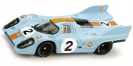 | NSR 0003SW Porsche 917K "Double Fin" GULF Livery #2 1971  NSR0003SW Porsche 917K "Double Fin" GULF Livery #2, Winner 1000km Monza 1971 - Sidewinder Shark Motor 20,000 RPM & 164gr-cm torque, setscrew aluminum wheels all around with air system... | $88.99
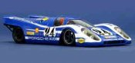 | NSR 02-#24 Porsche 917K #24, Porsche Salzburg, Le Mans 1970 (C)  Packaged in a plain cardboard box. From SET02. Motor: FC130 | $129.95
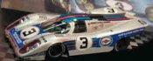 | NSR 03-#3 Porsche 917K #3, Martini Racing, Daytona 1970  Packaged in a plain cardboard box. From SET03. Motor: FC130 | $169.95
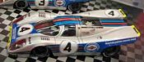 | NSR 03-#4 Porsche 917K #4, Martini Racing, Daytona 1970  Packaged in a plain cardboard box. From SET03. Motor: FC130 | $139.95
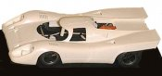 | NSR 1033 Porsche 917 white kit  NSR 1/32 RTR Car - Porsche 917K with White unpainted body kit - Includes 20,000 RPM Shark Motor Sidewinder with lightweight drilled aluminum setscrew wheels front & back, Lightweight drilled... | $93.99
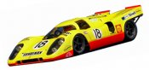 | NSR 1036 Porsche 917 LeMans 1970, Piper/VanLennep (C)  NSR 1/32 RTR Car - Porsche 917K LeMans 24 Hours 1970 #18 yellow Sandeman Livery - Drivers : David Piper and Gijs van Lennep - In cludes 20,000 RPM Shark FC130 motor sidewinder with... | $109.95
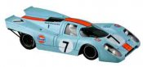 | NSR 1038 Porsche 917 Monza 1970, Gulf (C)  NSR 1/32 RTR Car - Porsche 917K, Monza 1970, Gulf livery. In cludes 20,000 RPM Shark FC130 motor sidewinder with lightweight drilled aluminum setscrew wheels front & back, Lightweight... | $129.95
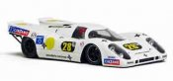 | NSR 1052 Porsche 917 #28 Buenos Aires  NSR 1/32 RTR Car - Porsche 917K Buenos Aires #28 Livery - Includes 20,000 RPM Shark FC130 Motor Sidewinder with lightweight drilled aluminum setscrew wheels front & back, Lightweight drilled... | $129.95
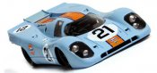 | NSR 1065 Porsche 917 Gulf #21. (C)  1/32 scale RTR slot car. Porsche 917K Gulf #21 24 Hours of LeMans Livery. Sidewinder Shark Motor 20,000 RPM & 164gr-cm torque, aluminum wheels all around with air system... | $149.95
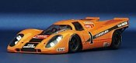 | NSR 1073 Porsche 917 Kyalami, Gunston. (C)  1/32 RTR Porsche 917K in Gunston livery as raced at Kyalami, South Africa. If you're into political incorrectness this is the car for you. Not only does it have a tobacco sponsor, it... | $149.95
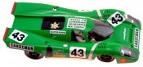 | NSR 1092SW Porsche 917 Sandeman #43  NSR 1/32 RTR Car - Porsche 917K Sandeman #43 David Piper Livery - Includes 20,000 RPM Shark FC130 Motor Sidewinder with lightweight drilled aluminum setscrew wheels front & back,... | $89.95
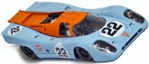 | NSR 1112SW Porsche 917 LeMans 24 Hours, Gulf #22 (C)  NSR 1/32 Analog RTR slot car. Porsche 917K Gulf Livery #22 LeMans 24 Hours - Sidewinder Shark Motor 20,000 RPM & 164gr-cm torque dynamically balanced motor, aluminum setscrew wheels all... | $110.95
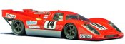 | NSR 1122SW Porsche 917 Brands Hatch 1970 (C)  1/32 RTR Porsche 917K ready to run on all 1/32 and 1/24 scale non-digital tracks. | $99.95
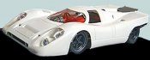 | NSR 1132SW Porsche 917 "double fin" plain white  NSR 1/32 Analog RTR slot car. Porsche 917K "Double Fin" White Body Unpainted - Sidewinder Shark Motor 20,000 RPM & 164gr-cm torque, setscrew aluminum wheels all around with... | $87.99
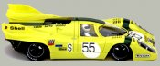 | NSR 1137SW Porsche 917 Nurburgring 1971, yellow #55 (C)  NSR 1/32 scale analog RTR slot car. Porsche 917K 1000km Nurburgring Yellow #55 - Sidewinder Shark Motor 20,000 RPM & 164gr-cm torque dynamically balanced motor - setscrew aluminum wheels all... | $149.95
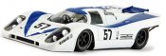 | NSR 1152SW Porsche 917 LeMans 1971, white/blue #57 (C)  NSR 1/32 Analog RTR slot car, Porsche 917K LeMans 1971 Livery #57 Blue / White - EVO Chassis with adjustable front axle ride height - Heat Treated Axles - Self Lubricating Bushings - Adjustable... | $129.95
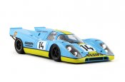 | NSR 1155SW Porsche 917K Gesipa Livery #14  1/32 scale analog slot car. 1000km Monza 1970. FEATURES: sidewinder Shark 20,000 rpm motor EVO chassis w/ adjustable front axle ride height aluminum setscrew wheels with Air System technology heat... | $105.99
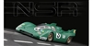 | NSR 1179SW Porsche 917K Piper Racing #3 Interserie Nurburgring 1972  NSR1179SW 1/32 Analog RTR Porsche 917K "Double Fin" Piper Racing #3 Interserie Nurburgring 1972 Livery - Sidewinder Shark Motor 20,000 RPM & 164gr-cm torque, aluminum wheels all around... | $109.99
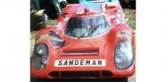 | NSR 1199SW Porsche 917K 1970 Sandeman Livery #59  NSR1199SW Porsche 917K 1970 Sandeman Livery #59 Magny Cours - Sidewinder Shark Motor 20,000 RPM & 164gr-cm torque - setscrew aluminum wheels all around with air system wheels at the rear | $88.99
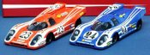 | NSR SET02 Porsche 917K 2-car set, LeMans 1970 (C)  2-car set in presentation box. Porsche Salzburg cars from LeMans 1970, including the race winner. ... | $279.95
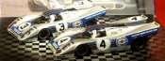 | NSR SET03 Porsche 917K 2-car set, Daytona 1971 (C)  The Martini Porsche 917Ks as they appeared at the Daytona 24 in 1971. | $279.95
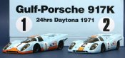 | NSR SET06 Porsche 917K 2-car set, Gulf, Daytona 1971 (C)  WAS $268.99 1/32 scale slot cars in special presentation box. The Gulf Porsche 917Ks as they appeared at the Daytona 24 in 1971. ... | $219.95
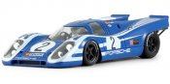 | NSR0017SW Porsche 917K #2 Targa Florio 1970 Vic Elford  NSR 1/32 Analog RTR Porsche 917K Blue w/White Stripes #2 Targa Florio 1970 Vic Elford - Sidewinder Shark Motor 20,000 RPM & 164g-cm torque - EVO Chassis with adjustable front axle ride height -... | $88.99

